Partial / residual correlation: GBPUSD and USDJPY
Method 07 / daily log returns / leave-currency-out USD factor / Alpari D1 full available history

Study setup
Logical pair: GBPUSD , USDJPY
Broker symbols: GBPUSD_i , USDJPY_i
Snapshot: 2026-11-03_majors_alpari_D1
Timeframe: D1
Matched return window: 1999-01-05 to 2026-11-02 (UTC bar dates)
Matched return count n: 7148
Dropped unfinished last bar dated 2026-11-03 UTC after a tick-volume check against the prior complete day.
USD-strength sign rule: minus log return when USD is the quote (EURUSD, GBPUSD, AUDUSD, NZDUSD); plus log return when USD is the base (USDJPY, USDCHF, USDCAD). EURGBP is never a constituent.
Control z constituents (5): EURUSD, AUDUSD, NZDUSD, USDCHF, USDCAD
z_t = equal-weight mean of those USD-strength returns on the same day
Complete matched rows (Excel): GBPUSD-USDJPY_Partial_D1.xlsx
Complete matched rows (HTML table): GBPUSD-USDJPY_Partial_D1_data.html

Method carried forward
Partial / residual correlation regresses each matched daily log return of close, ln(close_t / close_t-1), on the same leave-currency-out USD strength factor z, then takes Pearson correlation of the two residual series. Quotes are not inverted. z is the equal-weight mean of USD-strength returns from other majors that do not share a non-USD currency with either leg; EURGBP is never a constituent. USD-strength is minus the log return when USD is the quote (EURUSD, GBPUSD, AUDUSD, NZDUSD) and plus the log return when USD is the base (USDJPY, USDCHF, USDCAD). OLS uses an intercept on each leg. rho_partial is symmetric under swap of the two symbols. It describes leftover linear co-movement after removing linear z; it is not a cause, not a lead, and not a trading signal. Daily rows are not independent and residuals are estimated, so the two-sided p-value and Fisher interval are secondary. Same-sample raw Pearson r is a side check only.

Regression on z
leg | intercept_a_or_c | slope_b_or_d | R2
GBPUSD | -3.845e-05 | -0.71111518 | 0.43877825
USDJPY | 5.99e-05 | 0.277503 | 0.05526927

Results
rho_partial: -0.056112
Two-sided p-value: 2.06514e-06
Approximate 95% Fisher interval: [-0.079192, -0.032972]
Same-sample raw Pearson r: -0.196585
rho_partial minus r: 0.140473

Conclusion
Over 7148 matched daily rows for GBPUSD and USDJPY after removing a leave-currency-out USD factor built from 5 constituents, rho_partial is -0.0561 (negative, weak residual linear link in this sample). Approximate 95% Fisher interval: [-0.0792, -0.0330]. Same-sample raw Pearson r is -0.1966 (partial minus r = 0.1405). Leg R-squared on z: GBPUSD=0.4388, USDJPY=0.0553. Two-sided p under the usual independent-pairs model is 2.065e-06; residuals are estimated and daily FX rows are linked, so treat p as secondary. This does not establish cause, lead-lag, or a lasting trading rule.

Charts
Daily closes
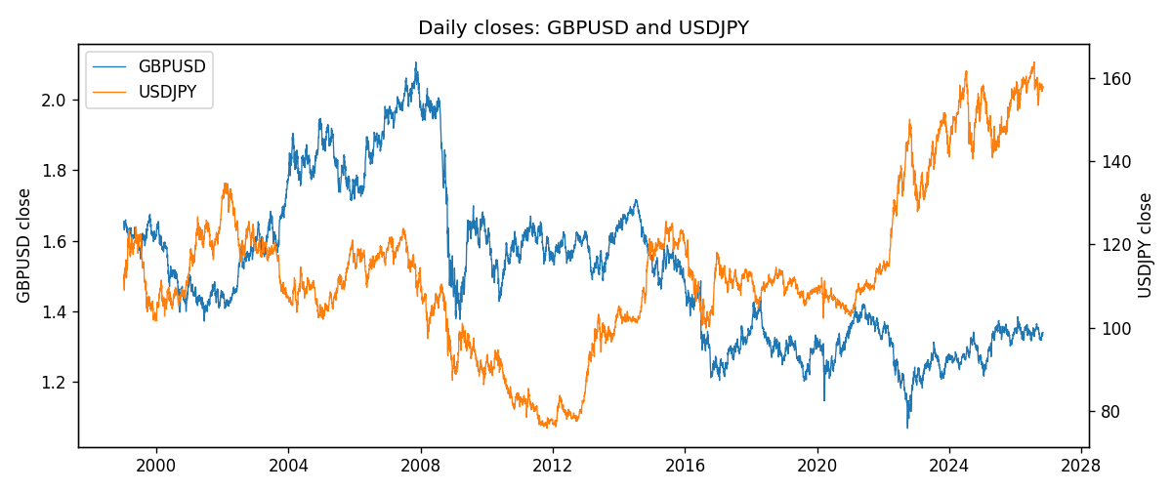
Log returns and control z
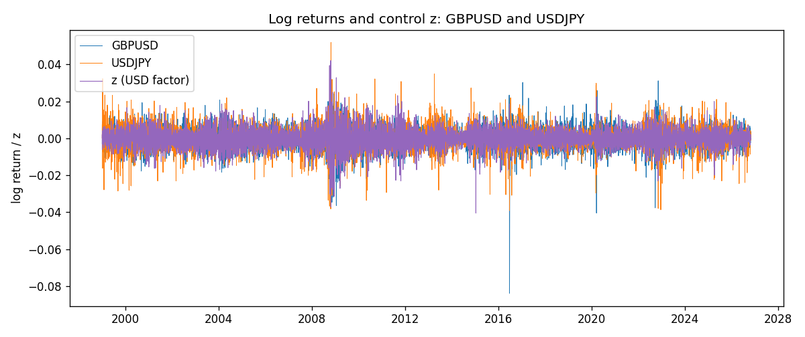
Residual scatter e_x vs e_y
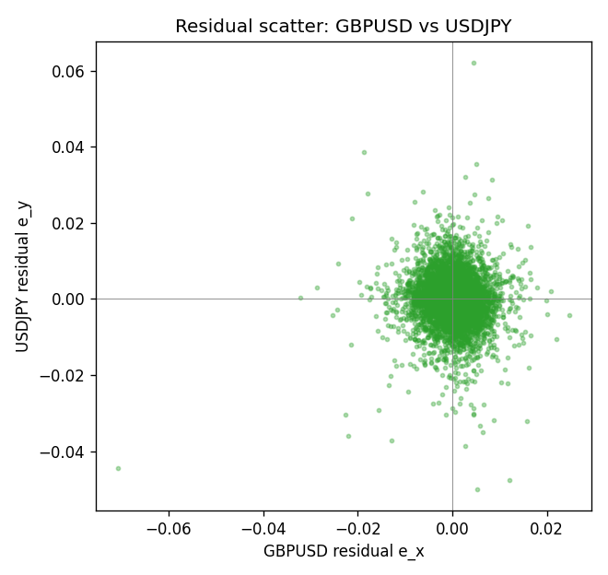

Data report
Every matched row that entered the partial correlation is stored in the sibling Excel workbook named GBPUSD-USDJPY_Partial_D1.xlsx. That file is the complete data archive for redrawing charts. Embedding all rows as a Word table is impractical at this length; the Word file holds the column list, column summaries, and the first and last 15 matched rows.
Columns: time, GBPUSD_open, USDJPY_open, GBPUSD_high, USDJPY_high, GBPUSD_low, USDJPY_low, GBPUSD_close, USDJPY_close, GBPUSD_tick_volume, USDJPY_tick_volume, GBPUSD_spread, USDJPY_spread, GBPUSD_real_volume, USDJPY_real_volume, GBPUSD_log_return, USDJPY_log_return, usd_strength_EURUSD, usd_strength_AUDUSD, usd_strength_NZDUSD, usd_strength_USDCHF, usd_strength_USDCAD, z, GBPUSD_fitted, USDJPY_fitted, GBPUSD_resid, USDJPY_resid
Column summaries (matched calculation rows)
column | count | mean | std | min | 25% | 50% | 75% | max
GBPUSD_open | 7148 | 1.5147424 | 0.21801364 | 1.06854 | 1.3240425 | 1.50985 | 1.629975 | 2.1066
USDJPY_open | 7148 | 113.80278 | 19.266728 | 75.693 | 104.3275 | 110.969 | 120.725 | 163.824
GBPUSD_high | 7148 | 1.5210395 | 0.21858109 | 1.08366 | 1.32902 | 1.516685 | 1.6374625 | 2.1161
USDJPY_high | 7148 | 114.30008 | 19.328348 | 76.001 | 104.8345 | 111.426 | 121.27175 | 163.978
GBPUSD_low | 7148 | 1.5084277 | 0.21724232 | 1.03518 | 1.3186875 | 1.50192 | 1.6233 | 2.0983
USDJPY_low | 7148 | 113.28032 | 19.194266 | 75.402 | 103.8475 | 110.515 | 120.19 | 163.628
GBPUSD_close | 7148 | 1.5148153 | 0.21797449 | 1.06879 | 1.324035 | 1.50993 | 1.6299575 | 2.1065
USDJPY_close | 7148 | 113.81631 | 19.281858 | 75.811 | 104.3175 | 110.995 | 120.7025 | 163.851
GBPUSD_tick_volume | 7148 | 95468.138 | 153933.58 | 62 | 10088.75 | 53396.5 | 92022.25 | 1273370
USDJPY_tick_volume | 7148 | 106851.22 | 179762.89 | 197 | 10008.25 | 53482.5 | 93111.75 | 1803508
GBPUSD_spread | 7148 | 26.846531 | 19.190643 | 0 | 10.75 | 20 | 50 | 50
USDJPY_spread | 7148 | 20.16704 | 17.582453 | 0 | 6 | 11 | 30 | 50
GBPUSD_real_volume | 7148 | 3.582457e+09 | 8.4750162e+10 | 0 | 0 | 0 | 0 | 2.4038164e+12
USDJPY_real_volume | 7148 | 3.4953653e+10 | 1.6133327e+11 | 0 | 0 | 0 | 0 | 3.8834203e+12
GBPUSD_log_return | 7148 | -1.992e-05 | 0.00564699 | -0.08388241 | -0.0031217 | 3.426e-05 | 0.00318167 | 0.03112653
USDJPY_log_return | 7148 | 5.267e-05 | 0.00620906 | -0.03908203 | -0.00319392 | 0.00012736 | 0.00340928 | 0.05184024
usd_strength_EURUSD | 7148 | 2.16e-06 | 0.0058013 | -0.03433183 | -0.00325609 | -0 | 0.00324218 | 0.03123819
usd_strength_AUDUSD | 7148 | -3.157e-05 | 0.00755018 | -0.0806166 | -0.00415111 | -0.00029168 | 0.00385014 | 0.08602525
usd_strength_NZDUSD | 7148 | -1.914e-05 | 0.00764519 | -0.05966839 | -0.004586 | -0.00023666 | 0.00424201 | 0.07027433
usd_strength_USDCHF | 7148 | -6.945e-05 | 0.0065937 | -0.19545699 | -0.00334697 | 8.15e-05 | 0.00331954 | 0.09051364
usd_strength_USDCAD | 7148 | -1.226e-05 | 0.00514518 | -0.03859748 | -0.00283513 | 4.873e-05 | 0.00272781 | 0.03436319
z | 7148 | -2.605e-05 | 0.00526017 | -0.04045841 | -0.00293801 | -5.701e-05 | 0.00290059 | 0.04206356
GBPUSD_fitted | 7148 | -1.992e-05 | 0.00374059 | -0.02995048 | -0.0021011 | 2.09e-06 | 0.00205082 | 0.02873215
USDJPY_fitted | 7148 | 5.267e-05 | 0.00145971 | -0.01116744 | -0.00075541 | 4.408e-05 | 0.00086482 | 0.01173266
GBPUSD_resid | 7148 | 0 | 0.00423043 | -0.07061442 | -0.0022159 | 5.313e-05 | 0.00230142 | 0.02464272
USDJPY_resid | 7148 | -0 | 0.00603503 | -0.04990881 | -0.0029649 | 0.00012115 | 0.00304462 | 0.0620791
First 15 matched rows (selected columns)
time | GBPUSD_close | USDJPY_close | GBPUSD_log_return | USDJPY_log_return | z | GBPUSD_fitted | USDJPY_fitted | GBPUSD_resid | USDJPY_resid
1999-01-05 | 1.6547 | 111.92 | -0.0028966287 | -0.00017868311 | 0.00026216295 | -0.00022487407 | 0.00013264656 | -0.0026717546 | -0.00031132967
1999-01-06 | 1.6537 | 112.77 | -0.00060452184 | 0.0075660159 | 0.002188206 | -0.0015945125 | 0.00066712928 | 0.00098999066 | 0.0068988866
1999-01-07 | 1.6502 | 111.33 | -0.002118709 | -0.012851583 | -0.0061315162 | 0.0043217682 | -0.0016416186 | -0.0064404772 | -0.011209964
1999-01-08 | 1.6405 | 110.8 | -0.0058954193 | -0.0047719894 | 0.0040264708 | -0.0029017305 | 0.0011772533 | -0.0029936888 | -0.0059492427
1999-01-11 | 1.6312 | 109.02 | -0.0056851331 | -0.016195423 | -0.0017251955 | 0.0011883667 | -0.00041885135 | -0.0068734998 | -0.015776571
1999-01-12 | 1.6349 | 112.6 | 0.0022657001 | 0.032310364 | 0.0004916273 | -0.00038804965 | 0.00019632361 | 0.0026537498 | 0.03211404
1999-01-13 | 1.6499 | 113.52 | 0.0091330396 | 0.0081373171 | -0.0013397184 | 0.00091424807 | -0.00031188031 | 0.0082187915 | 0.0084491975
1999-01-14 | 1.6531 | 113.52 | 0.0019376331 | 0 | 0.0014789102 | -0.0010901215 | 0.00047029756 | 0.0030277545 | -0.00047029756
1999-01-15 | 1.6502 | 114.15 | -0.0017558204 | 0.0055343401 | 0.0032049598 | -0.0023175416 | 0.0009492815 | 0.00056172117 | 0.0045850586
1999-01-18 | 1.6522 | 114.16 | 0.0012112405 | 8.7600193e-05 | -0.00098280772 | 0.00066044347 | -0.00021283653 | 0.00055079699 | 0.00030043672
1999-01-19 | 1.6553 | 113.52 | 0.0018745281 | -0.0056219403 | -0.0012467881 | 0.00084816393 | -0.00028609188 | 0.0010263642 | -0.0053358484
1999-01-20 | 1.6472 | 112.91 | -0.0049053846 | -0.0053879917 | -0.00017498509 | 8.5988541e-05 | 1.1336673e-05 | -0.0049913731 | -0.0053993283
1999-01-21 | 1.6524 | 113.87 | 0.0031518998 | 0.0084664056 | -0.0031941858 | 0.002232988 | -0.00082650058 | 0.0009189118 | 0.0092929062
1999-01-22 | 1.6565 | 114.56 | 0.0024781662 | 0.0060412564 | 0.0055746332 | -0.0040026523 | 0.001606873 | 0.0064808185 | 0.0044343834
1999-01-25 | 1.6585 | 113.72 | 0.0012066366 | -0.0073594164 | 0.0027690501 | -0.0020075596 | 0.00082831526 | 0.0032141962 | -0.0081877317
Last 15 matched rows (selected columns)
time | GBPUSD_close | USDJPY_close | GBPUSD_log_return | USDJPY_log_return | z | GBPUSD_fitted | USDJPY_fitted | GBPUSD_resid | USDJPY_resid
2026-10-13 | 1.32534 | 158.305 | 0.0036434319 | -0.0018932826 | -0.0038217621 | 0.002679267 | -0.0010006549 | 0.00096416483 | -0.00089262769
2026-10-14 | 1.31884 | 158.317 | -0.0049164679 | 7.5800166e-05 | 0.0026931006 | -0.0019535507 | 0.00080723903 | -0.0029629172 | -0.00073143887
2026-10-15 | 1.32757 | 158.024 | 0.0065976411 | -0.0018524319 | -0.0032439545 | 0.0022683793 | -0.00084031153 | 0.0043292618 | -0.0010121204
2026-10-16 | 1.33257 | 157.964 | 0.0037592051 | -0.00037976126 | -0.0035937039 | 0.0025170914 | -0.00093736805 | 0.0012421137 | 0.00055760679
2026-10-19 | 1.33024 | 158.517 | -0.0017500314 | 0.0034946841 | -0.00053732076 | 0.00034365093 | -8.921256e-05 | -0.0020936824 | 0.0035838967
2026-10-20 | 1.3377 | 158.16 | 0.0055923442 | -0.0022546642 | -0.0031809734 | 0.0022235925 | -0.0008228341 | 0.0033687518 | -0.0014318301
2026-10-21 | 1.33937 | 158.108 | 0.0012476328 | -0.00032883504 | -0.0015251393 | 0.0010461037 | -0.00036333516 | 0.00020152917 | 3.4500115e-05
2026-10-22 | 1.33967 | 156.755 | 0.00022396082 | -0.0085942669 | -0.00025372516 | 0.0001419818 | -1.0513931e-05 | 8.1979027e-05 | -0.008583753
2026-10-23 | 1.33684 | 156.81 | -0.0021146949 | 0.00035080446 | 0.00031000773 | -0.00025889722 | 0.00014592363 | -0.0018557977 | 0.00020488083
2026-10-26 | 1.33359 | 157.458 | -0.0024340661 | 0.0041238746 | 0.0020542469 | -0.0014992522 | 0.00062995522 | -0.00093481398 | 0.0034939194
2026-10-27 | 1.33044 | 157.894 | -0.0023648393 | 0.0027651658 | 0.0015794703 | -0.0011616313 | 0.00049820329 | -0.0012032081 | 0.0022669625
2026-10-28 | 1.33254 | 157.743 | 0.0015771808 | -0.00095679538 | -0.00028831878 | 0.00016658184 | -2.0113764e-05 | 0.0014105989 | -0.00093668162
2026-10-29 | 1.33733 | 157.683 | 0.0035881935 | -0.00038043789 | -0.0007539739 | 0.00049771627 | -0.00014933446 | 0.0030904773 | -0.00023110343
2026-10-30 | 1.33913 | 157.516 | 0.0013450605 | -0.0010596481 | -7.4739529e-05 | 1.4702398e-05 | 3.9155117e-05 | 0.0013303581 | -0.0010988032
2026-11-02 | 1.3406 | 157.933 | 0.0010971256 | 0.0026438521 | -0.0002273117 | 0.00012319879 | -3.1841178e-06 | 0.00097392678 | 0.0026470362

